One World Trade Center: Biography of the Building / Judith Dupré

#OneWTCBook OneWTCBook.com @OneWTCBook

For high-resolution photos, contact Carrie Neill, Publicity Manager, Little, Brown and Co.,
Carrie.Neill@hbgusa.com, o: 212.364.1437 c: 917.613.905

Professional Credits

Owner/Developer: The Port Authority of New York & New Jersey (PANYNJ)
Developer: The Durst Organization
Original Developer: World Trade Center Properties, LLC/ Silverstein Properties, Inc.
Leasing: PANYNJ; The Durst Organization; Cushman & Wakefield, Inc.
Architect: Skidmore, Owings & Merrill LLP (SOM). David M. Childs, Design Partner;
T. J. Gottesdiener, Managing Partner; Kenneth A. Lewis, Managing Director; Nicole Dosso, Senior Technical Architect
Structural Engineer of Record: WSP | Parsons Brinckerhoff. Ahmad Rahimian, Director of Building Structures; Silvian Marcus, Director of Building Structures
Main Contractor: Tishman/AECOM Construction Corp.

Photo captions and credit lines. Credit lines must be provided with all photos!

Gallery 1: OWTC and WTC overview | Suggested Caption | Required Credit Line
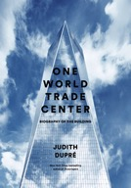 | Cover: One World Trade Center: Biography of the Building by Judith Dupré (Little, Brown and Company, 2016) | Courtesy Little, Brown and Company
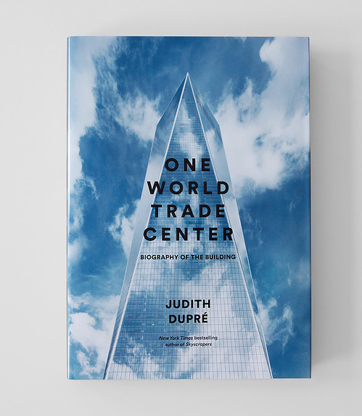 | Cover: One World Trade Center: Biography of the Building by Judith Dupré (Little, Brown and Company, 2016) | Courtesy Little, Brown and Company / Photo: DBOX
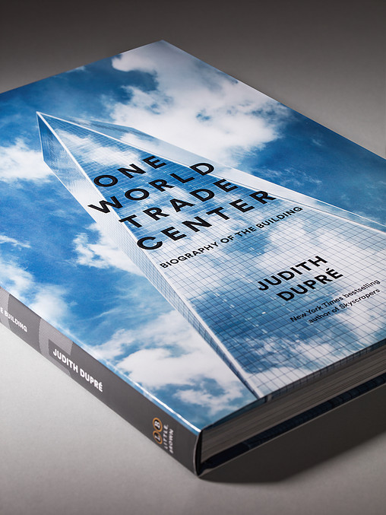 | Cover: One World Trade Center: Biography of the Building by Judith Dupré (Little, Brown and Company, 2016) | Courtesy Little, Brown and Company / Photo: DBOX
 | Author Judith Dupré | Joe Woolhead
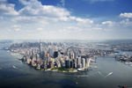 | One WTC has restored lower Manhattan’s skyline, as seen in this panoramic view. | © Nicola Lyn Evans / WSP | Parsons Brinckerhoff
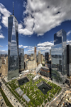 | The Port Authority of New York and New Jersey (PANYNJ) is responsible for the entire WTC site, which includes its own projects—One WTC, the Transportation Hub, and the Vehicle Security Center—and the infrastructure that is shared among the 9 major structures on the site. One World Trade Center examines each of these 9 structures in depth. | © The Port Authority of New York & New Jersey/Photo: Michael Mahesh
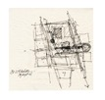 | One World Trade Center includes a number of architectural sketches, like this prescient one made on September 18, 2001 by lead architect David M. Childs of Skidmore, Owings & Merrill (SOM), that show the conceptual thinking behind the configuration of the future World Trade Center site. | © Skidmore, Owings & Merrill
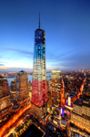 | SOM embedded the earliest symbols of the American democracy into their design of One WTC. Its obelisk form was modeled after the Washington Monument. Its symbolic height of 1,776 feet (541.3 m) refers to the year the Declaration of Independence was signed. | © The Port Authority of New York & New Jersey
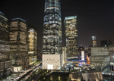 | Security concerns demanded a complete redesign of One WTC in 2005. Architects Skidmore, Owings & Merrill designed a new luminous base that conceals the tower’s lower concrete walls. | © Nicola Lyn Evans / WSP | Parsons Brinckerhoff
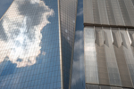 | A gentle giant, One WTC meets its Janus task—to stand tall while avoiding any appearance of hubris—by inviting into its glass surface everything around it. | © Nicola Lyn Evans / WSP | Parsons Brinckerhoff
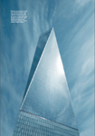 | When viewed from certain angles, four of One WTC’s planes morph into pyramidal forms. The tower’s tapered silhouette references obelisks and pyramids, two ancient commemorative types. | Courtesy Little, Brown and Company / Photo: DBOX
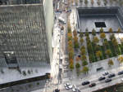 | OWTC and the 9/11 Memorial derive their physical dimensions and symbolic meaning from the original Twin Towers. OWTC’s luminous podium echoes, in reverse, the image of the dark memorial pools, a connection that is heightened because the podium’s measurements—200 feet (61.0 m) wide by 186 feet (56.7 m) high—replicate the size of the memorial pools almost exactly. | © The Port Authority of New York & New Jersey
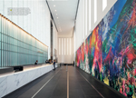 | Visitors to One WTC’s lobby are greeted by ONE: Union of the Senses, a vibrant 90-foot-long (27.5 m) mural painted by José Parlá, an artist who draws inspiration from calligraphic street graffiti. | Courtesy Little, Brown and Company / Photo: DBOX
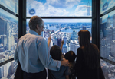 | Sky Pods, five state-of-the-art ThyssenKrupp elevators, among the fastest in the world, whisk visitors up 1,268 feet (386.5 m) to One World Observatory, the highest public vantage point in Manhattan. Floor-to-ceiling time-lapse displays on the cab walls show the evolution of Manhattan architecture over the past five hundred years. | The Hettema Group / Photo: Evan Joseph
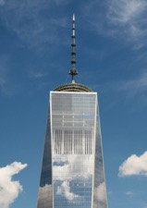 | The 1,776’ tower is crowned with a 408-foot (124.4 m) steel spire that is encircled by a three-level communications platform. Much like a tree, the spire telescopes upward, gradually tapers, and culminates in a steel and glass beacon. The beacon, the last piece of the tower, was hoisted to the top of the spire in May 2013. | © Nicola Lyn Evans / WSP | Parsons Brinckerhoff
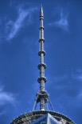 | One WTC spire detail | © The Port Authority of New York & New Jersey

Gallery 2: OWTC Construction Milestones | Suggested Caption | Required Credit Line
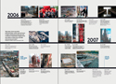 | A Construction Timeline documents building milestones from April 2006, when the construction of One WTC began, to September 2015. The timeline is illustrated with dozens of photos, many of them never published before. | Courtesy Little, Brown and Company / Design: DBOX
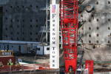 | One WTC’s first steel—two massive columns, more than 30 feet (9.1 m) long and weighing 49,579 pounds (22,488.7 kg) and 53,342 pounds (24,195.5 kg)—was raised on Dec. 19, 2006. | © The Port Authority of New York & New Jersey
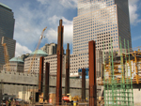 | On May 17, 2008, One WTC’s steel columns rose above grade for the first time, marking the transition from substructure to superstructure. | © The Port Authority of New York & New Jersey
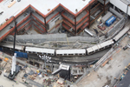 | An aerial view shows a PATH train running through the site. Because the PATH and No. 1 trains had to remain operational during construction, early building strategies were critical. | © The Port Authority of New York & New Jersey
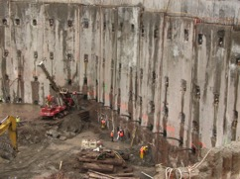 | Federal laws protected the structural artifacts that survived 9/11—the slurry walls (shown here), the box columns that once formed the perimeters of the Twin Towers, and the Vesey Street staircase. These artifacts can be viewed at the 9/11 Memorial Museum. A smaller section of the slurry wall also can be seen also inside the PATH Station, Platform A. | © The Port Authority of New York & New Jersey
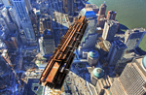 | A massive steel beam is lifted to the top of One WTC. One WTC’s superstructure consumed 45,000 tons (408,023.3 metric tons) — ninety million pounds — of structural steel, 90% of it recycled. | © The Port Authority of New York & New Jersey
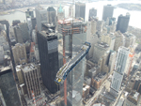 | ThyssenKrupp designed and installed One WTC’s 71 elevators and 12 escalators. In December 2012, the last two escalators were hoisted by crane up to the 100th floor. The sight of an escalator floating in the sky captured people’s imaginations—photos of the operation, taken by Scott Lahmers, a technical specialist at ThyssenKrupp Elevator, went viral. | © ThyssenKrupp Elevator/Scott Lahmers
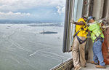 | Workers install one of more than 13,000 glass panels that make up One WTC’s curtain wall. One million square feet (92,903 m2) of crystal-clear glass — the safest, most sustainable, and largest panels ever to clad a skyscraper — cover its upper reaches. | © The Port Authority of New York & New Jersey

Gallery 3: Other WTC  Buildings | Suggested Caption | Required Credit Line
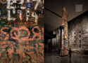 | Foundation Hall at the 9/11 Memorial Museum houses the Last Column, a thirty-six-foot-tall (11 m) column that was salvaged from the South Tower. Covered with photographs, mementos, and inscriptions from recovery workers, it was the last load to be removed from Ground Zero in 2002. Beyond the column is the slurry wall, now a symbol of American resilience. | Courtesy Little, Brown and Company / Photo: DBOX
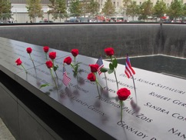 | Bronze parapets around the 9/11 Memorial pools commemorate the 2,983 victims of the 1993 and 2001 WTC attacks. Their names are cut into the parapet panels, inviting visitors to run their fingers over them, one of the most ancient forms of homage. | © The Port Authority of New York & New Jersey
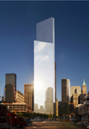 | Although 4 WTC is a 72-story skyscraper, the self-effacing glass tower seems to disappear into surroundings. Designed by Japanese master architect Fumihiko Maki, the tranquil tower is a response to the devastation of 9/11. | © Maki and Associates / Photo: Tectonic
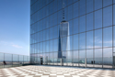 | In a gesture of respect and homage, the façade of 4 WTC is angled to reflect the image of One WTC in its glass façade. | © Bednorz–Images 2015
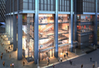 | Since New Yorkers traditionally prefer shopping at street level, three floors of shops at 3 WTC are easily visible and accessible from the sidewalk; two additional retail levels are below ground. | © Silverstein Properties, Inc.
 | The Transportation Hub’s 114 steel rafters cantilever out from the structure’s arches. Placed asymmetrically, the rafters mirror each other: On the northern side, the rafters are shorter; to the south, they extend to their full length of 140 feet (42.7 m). | Courtesy Little, Brown and Company / Photo: DBOX
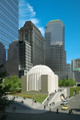 | St. Nicholas National Shrine’s dome was inspired by that of the Hagia Sophia, a religious and engineering landmark built in the sixth century in Constantinople, now Istanbul. Architect Santiago Calatrava describes the diminutive Greek Orthodox church as a “human-scaled presence in an ensemble of giants.” | © 2014 Santiago Calatrava LLC. All rights reserved.
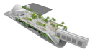 | Liberty Park is a 1.5 acre (0.6 ha) park that sits atop the Vehicle Security Center. Animated by colorful seasonal plantings and multiple seating areas, the park connects the Trade Center to Battery Park City. | © Downtown Streetscape Partnership, a joint venture of AECOM and Jacobs

Gallery 4: Book Graphic Design Features | Suggested Caption | Required Credit Line
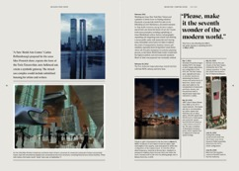 | The first chapter features an illustrated timeline from September 12, 2001 until 2005 that examines the many extraordinary proposals for rebuilding of Ground Zero. | Courtesy Little, Brown and Company / Design: DBOX
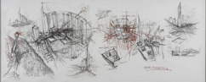 | Daniel Libeskind’s “Memory Foundations” sketch established critical conceptual parameters for the rebuilding of the Trade Center. | © Daniel Libeskind
 | Dozens of investigatory models broke open SOM’s thinking about One WTC’s design. Remnants of earlier design proposals remain, but their geometries have been blended in new ways, yielding the final design of 2005. | © Skidmore, Owings & Merrill
 | The book includes full color renderings of the WTC as it will appear when it is completed in 2020. | Courtesy Little, Brown and Company / Rendering: DBOX
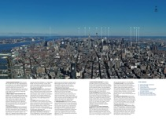 | Four annotated, panoramic photos taken from One World Observatory pinpoint the region’s major architectural landmarks from an aerial perspective. | Courtesy Little, Brown and Company / Design: DBOX
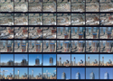 | OWTC’s incremental growth was captured in time-lapse photographs taken by EarthCam, a company that has tracked the recovery and construction of the site since 2001. | © EarthCam, Inc.
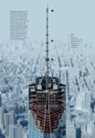 | Dramatic cutaway diagrams like this one of the top of One WTC show the building’s advanced structural technologies. | Courtesy Little, Brown and Company / Rendering: DBOX

